Excel Class-1

| Table of content:  Agenda:  Dataset used for the class:  Overview of Excel Interface |
| --- |

### Agenda:

* Overview of excel interface
* Cell referencing and Table referencing in formulas
* Functions/formulas in Excel
  + Sum
  + Sumif
  + Countif
  + Max
  + If
  + Concat
  + Date function
  + Text functions
    - Left
    - Right
    - Handling errors using the iferror function

### Dataset used for the class:

IPL data: <https://docs.google.com/spreadsheets/d/1gvefNcjEwjSDKzqA0sQ1TFoE0XV8GSIt/edit?usp=share_link&ouid=101036715917275623123&rtpof=true&sd=true>

### Overview of Excel Interface

1. High level Tool layout

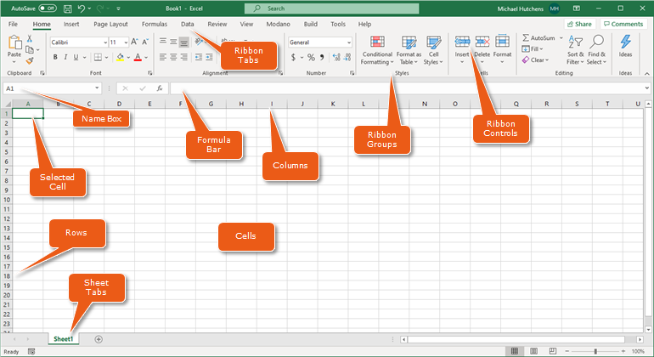

1. Changing Column width
   1. Step-1: Select the cell B2 and click on format for cells

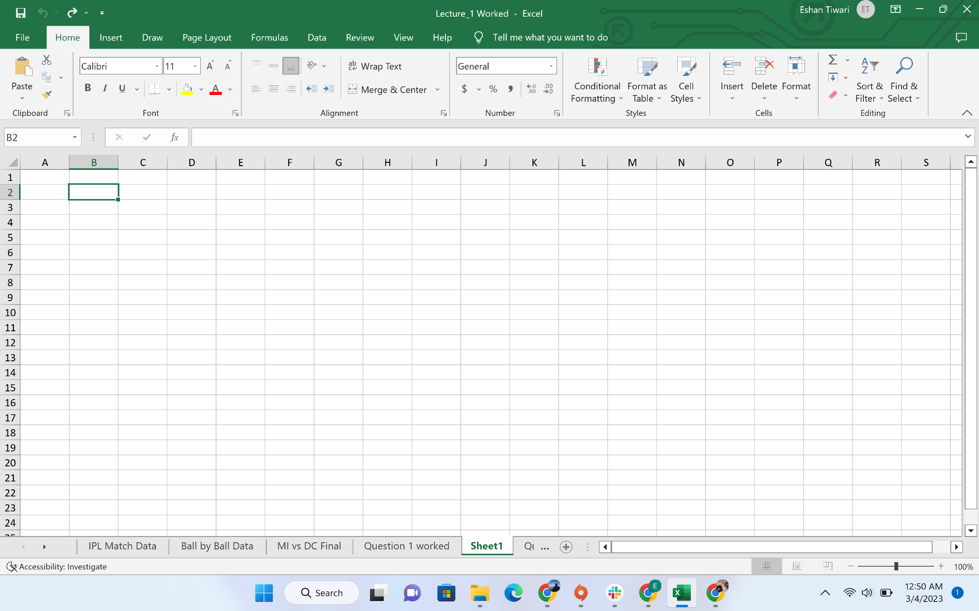

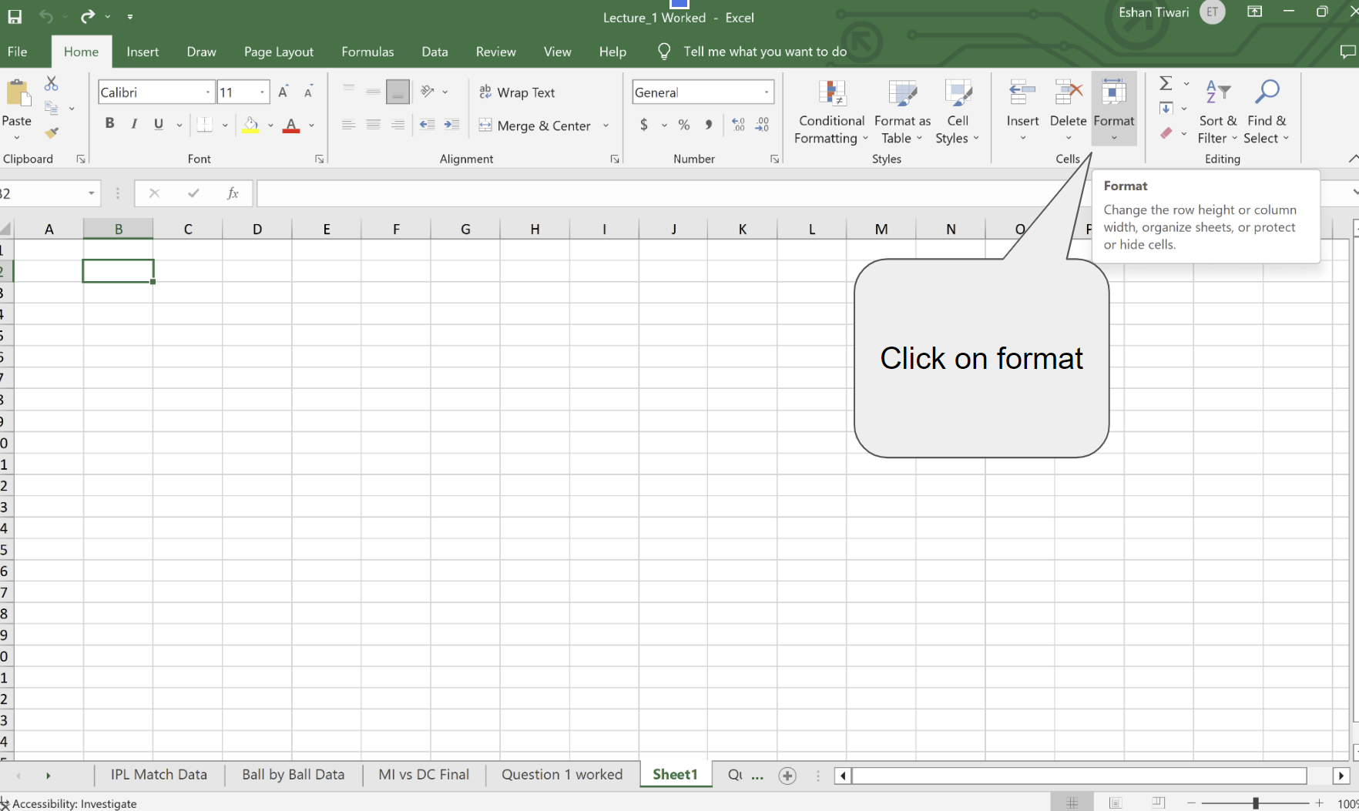

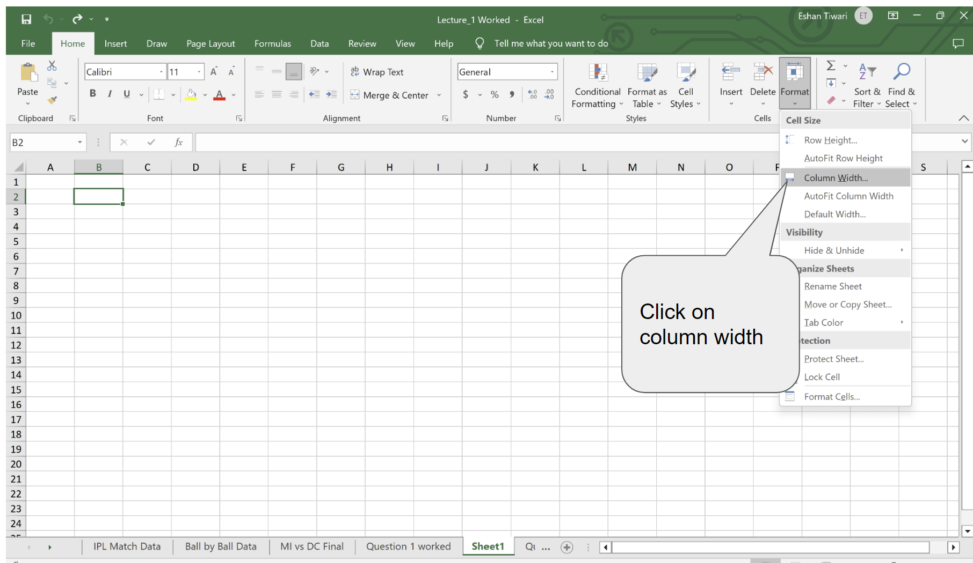

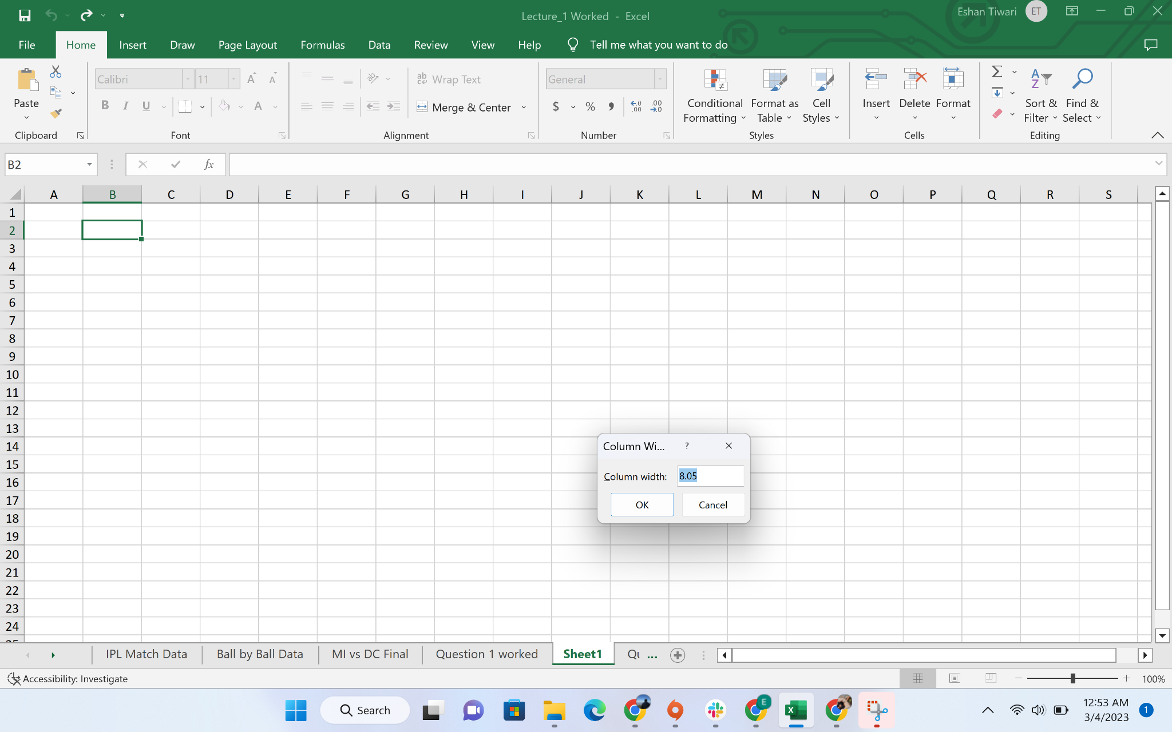

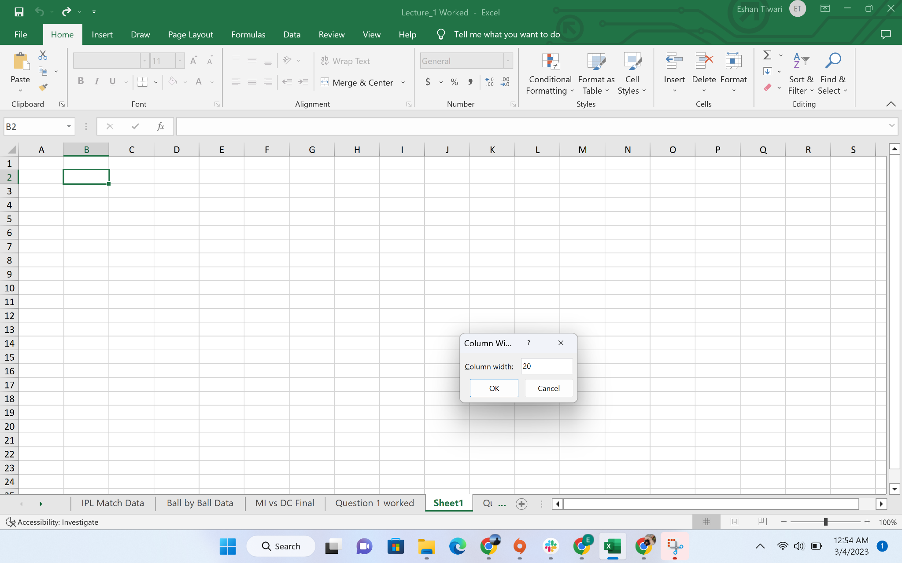

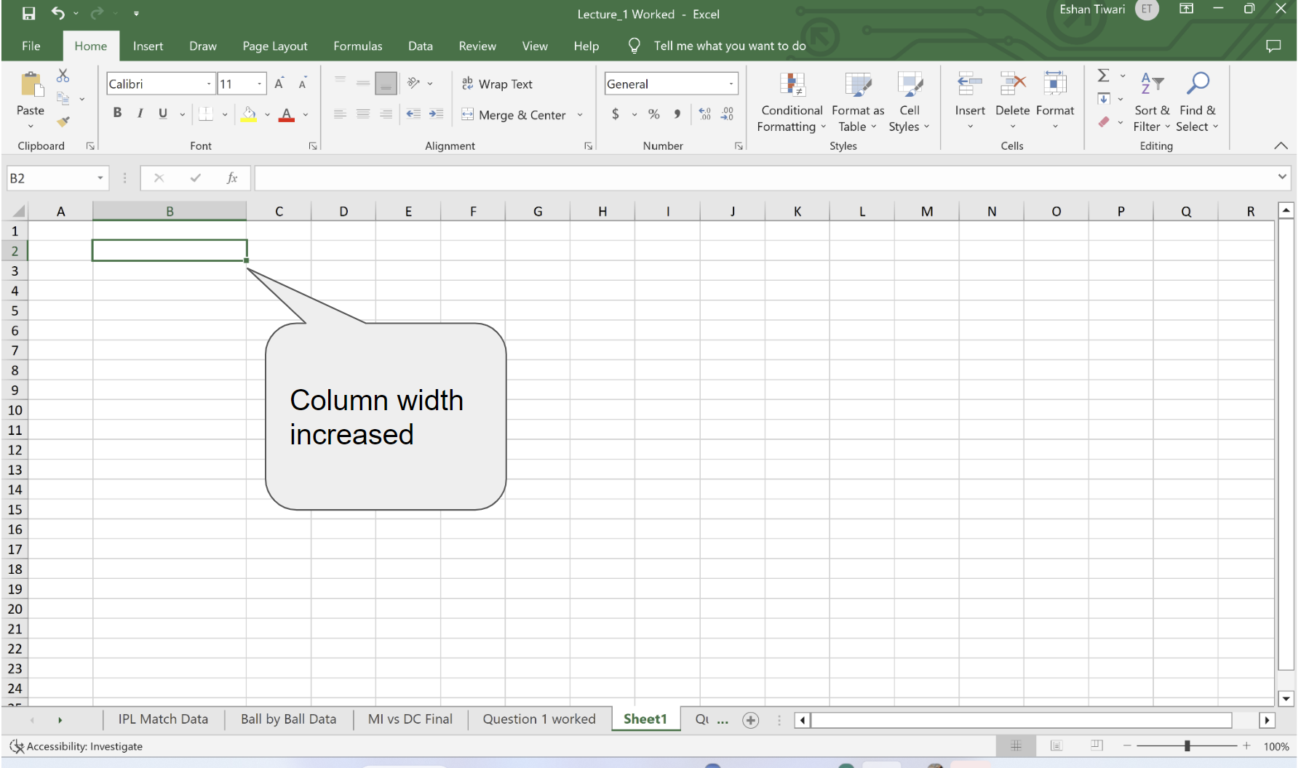

Creating Table in Excel:

## How to create a table in Excel

With the source data organized in rows and columns, carry out the below steps to covert a range of cells into a table:

1. Select any cell within your data set.
2. On the *Insert* tab, in the *Tables* group, click the Table button or press the Ctrl + T shortcut.
3. The *Create Table* dialog box appears with all the data selected for you automatically; you can adjust the range if needed. If you want the first row of data to become the table headers, make sure the My table has headers box is selected.
4. Click *OK*.

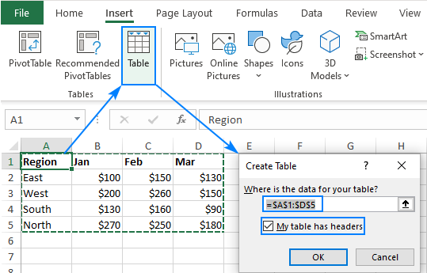

As the result, Excel converts your range of data into a true table with the default style:

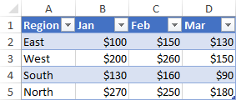

Many wonderful features are now just a click away and, in a moment, you will learn how to use them. But first, we'll look at how to make a table with a specific style.

Tips and notes:

* Prepare and clean your data before creating a table: remove blank rows, give each column a unique meaningful name, and make sure each row contains information about one record.
* When a table is inserted, Excel retains all formatting that you currently have. For best results, you may want to remove some of the existing formatting, e.g. background colors, so it does not conflict with a table style.
* You are not limited to just one table per sheet, you can have as many as needed. For better readability, it stands to reason to insert at least one blank row and one blank column between a table and other data.

## How to make a table with a selected style

The previous example showed the fastest way to create a table in Excel, but it always uses the default style. To draw a table with the style of your choosing, perform these steps:

1. Select any cell in your data set.
2. On the *Home* tab, in the *Styles* group, click Format as Table.
3. In the gallery, click on the style you want to use.
4. In the *Create Table* dialog box, adjust the range if necessary, check the *My table has headers* box, and click *OK*.

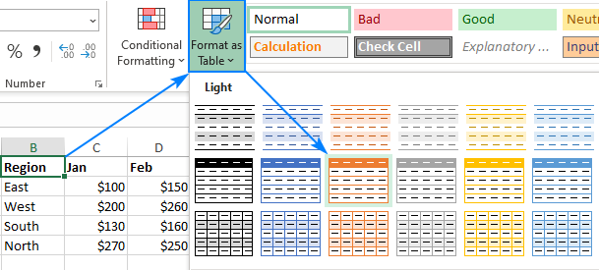

Tip. To apply the selected style and remove all existing formatting, right-click the style and choose *Apply and Clear Formatting* from the context menu.

## How to name a table in Excel

Every time you make a table in Excel, it automatically gets a default name such as*Table1*, *Table2*, etc. When you deal with multiple tables, changing the default names to something more meaningful and descriptive can make your work a lot easier.

To rename a table, just do the following:

1. Select any cell in the table.
2. On the *Table Design* tab, in the *Properties* group, select the existing name in the Table Name box, and overwrite it with a new one.

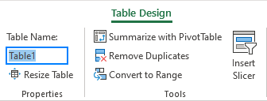

Tip. To view the names of all tables in the current workbook, press Ctrl + F3 to open the *Name Manager*.

## How to use tables in Excel

Excel tables have many awesome features that simply calculating, manipulating and updating data in your worksheets. Most of these features are intuitive and straightforward. Below you will find a quick overview of the most important ones.

### How to filter a table in Excel

All tables get the auto-filter capabilities by default. To filter the table's data, this is what you need to do:

1. Click the drop-down arrow in the column header.
2. Uncheck the boxes next to the data you want to filter out. Or uncheck the *Select All* box to deselect all the data, and then check the boxes next to the data you want to show.
3. Optionally, you can use the Filter by Color and Text Filters options where appropriate.
4. Click *OK*.

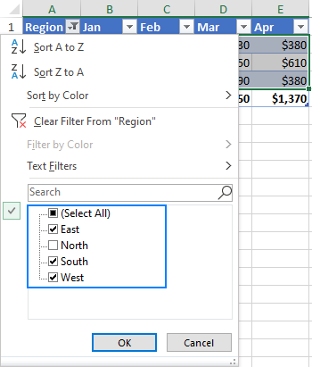

If you don't need the auto-filter feature, you can remove the arrows by unchecking the *Filter Button* box on the *Design* tab, in the *Table Style Options* group. Or you can toggle the filter buttons on and off with the Ctrl + Shift + L shortcut.

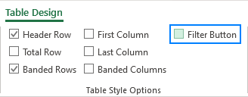

Additionally, you can create a visual filter for your table by adding a [slicer](https://www.ablebits.com/office-addins-blog/excel-slicer-pivot-table-chart/). For this, click *Insert Slicer* on the *Table Design* tab, in the *Tools* group.

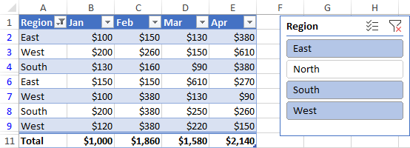

### How to sort a table in Excel

To sort a table by a specific column, just click the drop-down arrow in the heading cell, and pick the required sorting option:

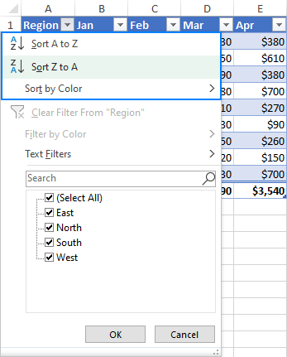

### Excel table formulas

For calculating the table data, Excel uses a special formula syntax called [structured references](https://www.ablebits.com/office-addins-blog/structured-references-excel-tables/). Compared to regular formulas, they have a number of advantages:

* Easy-to-create. Simply select the table's data when making a formula, and Excel will build a structured reference for you automatically.
* Easy-to-read. Structured references refer to the table parts by name, which makes formulas easier to understand.
* Auto-filled. To perform the same calculation in each row, enter a formula in any single cell, and it will be immediately copied throughout the column.
* Changed automatically. When you modify a formula anywhere in a column, the other formulas in the same column will change accordingly.
* Updated automatically. Every time the table is resized or the columns renamed, structured references update dynamically.

The screenshot below shows an example of a structured reference that sums data in each row:

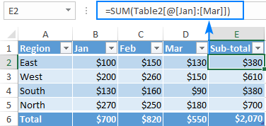

### Sum table columns

Another great feature of an Excel table is the ability to summarize data without formulas. This option is called Total Row.

To sum a table's data, this is what you need to do:

1. Select any cell in the table.
2. On the *Design* tab, in the *Table Style Options* group, put a tick mark in the *Total Row box.*

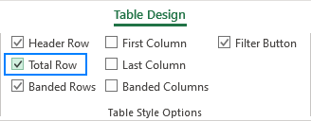

The *Total* row is inserted at the bottom of the table and shows the total in the last column:

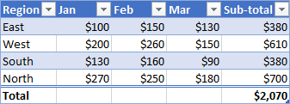

To sum data in other columns, click in the *Total* cell, then click the drop-down arrow and choose the SUM function. To calculate data in a different way, e.g. count or average, select the corresponding function.

Whatever operation you choose, Excel would use the SUBTOTAL function that calculates data only in visible rows:

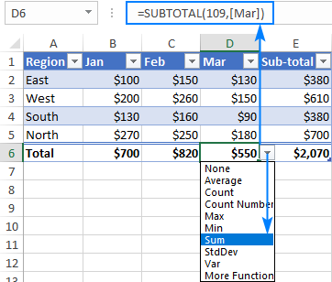

Tip. To toggle the Total Row on and off, use the Ctrl + Shift + T shortcut.

### How to extend a table in Excel

When you type anything in an adjacent cell, an Excel table expands automatically to include the new data. Combined with structured references, this creates a dynamic range for your formulas without any effort from your side. If you don't mean the new data to be part of the table, press Ctrl + Z. This will undo the table expansion but keep the data that you typed.

You can also extend a table manually by dragging a little handle at the bottom-right corner.

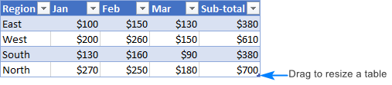

You can also add and remove columns and rows by using the Resize Table command. Here's how:

1. Click anywhere in your table.
2. On the *Design* tab, in the *Properties* group, click Resize Table.
3. When the dialog box appears, select the range to be included in the table.
4. Click *OK*.

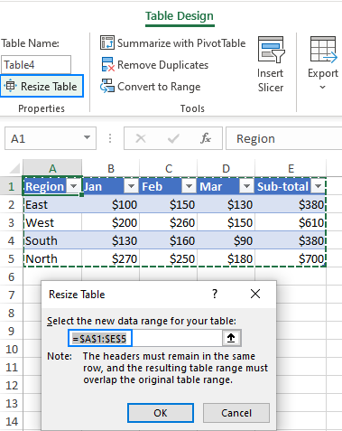

## Excel table styles

Tables are very easily formatted due to a predefined gallery of styles. Additionally, you can create a custom style with your own formatting.

### How to change table style

When you insert a table in Excel, the default style is automatically applied to it. To change a table style, do the following:

1. Select any cell in the table.
2. On the *Design* tab, in the *Table Styles* group, click on the style you want to apply. To see all the styles, click the *More* button in the down-right corner.

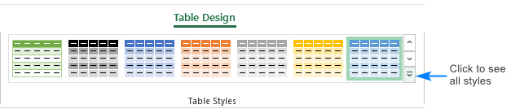

### Apply a table style and remove existing formatting

When you format a table with any predefined style, Excel preserves the formatting you already have. To remove any existing formatting, right-click the style and choose Apply and Clear formatting:

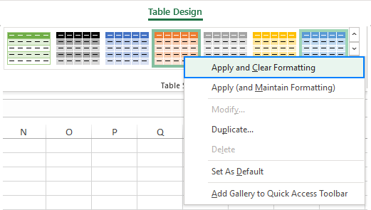

### Manage banded rows and columns

To add or remove banded rows and columns as well as apply special formatting for the first or last column, simply tick or untick the corresponding checkbox on the *Design* tab in the *Table Style Options* group:

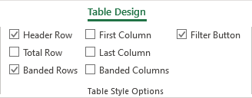

## How to remove table formatting

If you'd like to have all the functionality of an Excel table but do not want any formatting such as banded rows, table borders and the like, you can remove formatting in this way:

1. Select any cell within your table.
2. On the *Design tab*, in the *Table Styles* group, click the *More* button in the bottom-right corner, and then click Clear underneath the table style templates. Or pick the first style under *Light*, which is called None.

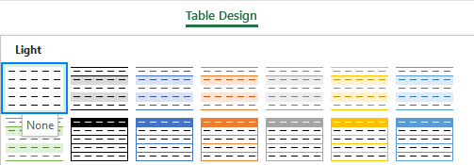

Note. This method only removes the inbuilt table formatting, your custom formatting is preserved. To remove absolutely all formatting in a table, go to the *Home* tab > *Formats* group, and click Clear > Clear formats.

## How to remove table in Excel

Removing a table is as easy as inserting it. To convert a table back to a range, just do the following:

1. Right-click any cell in your table, and then click *Table*> *Convert to Range*. Or click the Convert to Range button on the *Design* tab, in the *Tools* group.
2. In the dialog box that appear, click *Yes*.

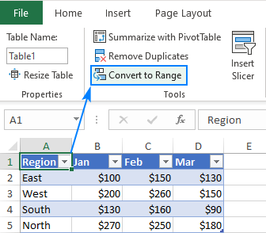

This will remove the table but retain all the data and formatting. To keep only the data, remove table formatting before converting your table to a range.

### Business Problem-1: Total number of runs scored by Delhi capitals

### Business Problem-2: How many Extras runs were given by DC to MI in 2nd innings?

### Business Problem-3: Find number of wickets lost by MI

### Business Problem-4: Get run rate for DC in 1st 5 overs

### Business Problem-5: Find the number of wickets that were lost in the first five overs for DC

### Business Problem-6: Question-6 From the match id 1237181, given the list of batsmen which were out during the match, if they were out by a catch we need to display the bowler and the fielder in this format "c fielder_name b bowler_name" (As shown on the cricket match summary/score card)

### 

### Business Problem-7: Question-7 If the player is dismissed by bowling, then display the output as “b bowler_name”

### 

### Business Problem-8:Question-8

### If the player is dismissed by run-out, then display the output as “run out (fielders_name)”

### 

### Business Problem-9:Write a formula/function that combines all the three outputs of the previous three questions in one i.e. depending on how the player is out the output should be displayed in an appropriate format.

#### 